**ASSIGNMENT 2**

NAME : RAJARSHI CHOWDHURY

UNIVERSITY ROLL : 11500120095

CSE B 3rd year

1. (a) In class Employee created in Assignment 1 add static instance field emp_count.Use

emp_count for getting emp_id in proper sequence. Also include appropiate accessor method

for the instance field emp_count

    (b) Write a static method in Employee class.

(c) Write methods to compare two Employees based upon their salary and return

object having higher salary.

    (d) Write two overloading methods in your Employee class.

    (e) Use final keyword for creating a constant field.

**CODE :**

import java.util.*;

class Employee{

private String name;

private int employee_id;

private int salary;

private String designation;

static int emp_count;

public final String comp = "TCS";

public static Employee maxsal(Employee e1, Employee e2){

if (e1.ret_sal() >= e2.ret_sal() ) return e1;

else return e2;

}

public static Employee maxsal(Employee e1, Employee e2, Employee e3){

if (e1.ret_sal() >= e2.ret_sal() && e1.ret_sal() >= e3.ret_sal()) return e1;

if (e2.ret_sal() >= e1.ret_sal() && e2.ret_sal() >= e3.ret_sal()) return e2;

if (e3.ret_sal() >= e1.ret_sal() && e3.ret_sal() >= e2.ret_sal()) return e3;

return e1;

}

Employee(String name)

{

this.name=name;

this.employee_id= ++emp_count;

this.salary=26100;

this.designation="trainee";

}

Employee(String name,int salary,String designation)

{

this.name=name;

this.employee_id= ++emp_count;

this.salary=salary;

this.designation=designation;

}

Employee()

{

this.name="Eriksen" ;

this.employee_id= ++emp_count;

this.salary=5000;

this.designation="part_time_employee";

}

public int ret_sal(){

return this.salary;

}

public String ret_name(){

return this.name;

}

public void display()

{

System.out.println("Name : "+name);

System.out.println("Employee id : "+employee_id);

System.out.println("Salary : " +salary);

System.out.println("Designation : "+designation);

System.out.println("Company Name : "+comp);

System.out.println();

}

}

class Grogu{

public static void main(String args[]){

Employee fresher=new Employee("Bruh");

fresher.display();

Employee executive=new Employee("Lisandro",36200,"executive officer");

executive.display();

Employee part_time_member=new Employee();

part_time_member.display();

System.out.println("Comparing salary of employee 1 and 3 :");

System.out.println(fresher.maxsal(fresher, part_time_member).ret_name() + " has higher salary");

System.out.println("Comparing salary of all 3 employees :");

System.out.println(fresher.maxsal(fresher, executive, part_time_member).ret_name() + " has highest salary");

}

}

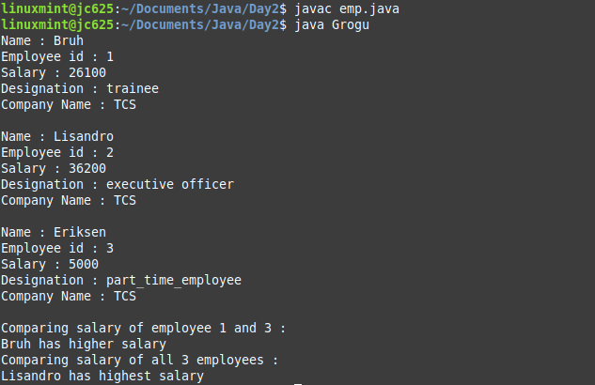

1. **Write a java program to illustrate - “Java uses pass by value”.**

**CODE :**

import java.util.*;

class Employee{

private String name;

private int employee_id;

private int salary;

private String designation;

static int emp_count;

Employee(String name)

{

this.name=name;

this.employee_id= ++emp_count;

this.salary=26100;

this.designation="trainee";

}

Employee(String name,int salary,String designation)

{

this.name=name;

this.employee_id= ++emp_count;

this.salary=salary;

this.designation=designation;

}

Employee()

{

this.name="Eriksen" ;

this.employee_id= ++emp_count;

this.salary=5000;

this.designation="part_time_employee";

}

public static void swap(Employee a, Employee b){

Employee temp = a;

a = b;

b = temp;

}

public void display()

{

System.out.println("Name : "+name);

System.out.println("Employee id : "+employee_id);

System.out.println();

}

}

class Swap{

public static void main(String args[])

{

Employee a = new Employee("Bruh");

a.display();

Employee b = new Employee("Lisandro",36200,"executive officer");

b.display();

System.out.println("After swap : ");

a.swap(a,b);

a.display();

b.display();

}

}

